Electrical Engineering 475

**Final Project : E Vending Machine**

March 12, 2018



**Ivan Tarasyuk**

**John Sommers**

**Pyi Thein Khine**

# 

Abstract 3

Introduction 4

Lab Discussion 4

Design Specification 4

External Environment 4

Inputs 4

Outputs 4

User Interface 5

Design Procedure 5

Exterior Box and Interior Compartments 5

Coin Counter 6

Product Dispenser 7

Change Dispenser 8

System Description 9

System Inputs 9

System Outputs 10

User Interface 10

Physical Structure Specification 10

System Functional Specification 11

Operating Specification 11

Software Implementation 11

Pic 1 12

Pic 2 12

Wifi 13

LCD Display 14

KeyPad 15

Coin Counter 16

Change Dispenser 16

Wifi 16

Product dispenser 17

Memory 17

Hardware Implementation 17

LCD Display 17

KeyPad 18

Coin Counter 19

Change Dispenser 21

Wifi 22

Product dispenser 23

Memory 24

Test Plan 24

Test Specification 25

LCD Display 25

KeyPad 25

Coin Counter 25

Change Dispenser 25

Wifi 26

Product dispenser 26

Memory 26

Test Cases 26

LCD Display 26

KeyPad 27

Coin Counter 27

Change Dispenser 28

Wifi 28

Product dispenser 28

Memory 28

Analysis of Results 29

LCD Display 30

KeyPad 30

Coin Counter 31

Change Dispenser 31

Wifi 31

Product dispenser 31

Memory 32

Analysis of Errors 32

Summary 33

Conclusion 33

Citations 33

Hardware 34

Pic 1 Code 36

Code for Pic 2 49

Code for Wifi Module 54

# Abstract

The following report is about the EE475 Final Project. This project consists of an E vending machine that dispenses common EE items such as batteries, LEDS, among other small electronic components. The machine accepts quarters, nickels, and dimes as valid forms of payment. This report will analyze and describe the system’s hardware and software implementation, the various testing/experiments, the finished product, and any errors encountered during prototyping.

The software was written on two pics (Pic18f25k22) to support the various hardware parts. The main components are the LCD display screen, keypad, coin counter, change dispenser, wifi, and the product dispenser. All these parts are assembled in a wooden box that resembles a typical commercial vending machine.

The vending machine was rigorously tested through the development process. Each major part was first tested on its own for any future and present bugs. After that, the system was tested every time parts were integrated together.

The finished prototype was a success. Every major part works as expected, however, there was still room for improvement.

There were many errors and setbacks encountered in this lab. The vending machine’s interior compartment for circuit boards and coin mechanisms were made too small. Furthermore, the four wifi modules were bricked on arrival and EEPROM did not function properly. Additionally, the length of the item dispensing coils was not ideal. More details on errors and setbacks are described in *Analysis of Errors* section.

In conclusion the project was a success and was able to meet all basic functional requirements, delivering the product to the consumer in a efficient and controlled fashion.

# **Introduction**

Almost every student in the embedded systems concentration and the EE department at UW has spent many long nights in the lab. There is no worse feeling than realizing that you forgot to buy or burned an electrical component that is crucial for your lab to work. This common struggle inspired the development of a cheap and practical solution to the problem, the E-vending machine. This vending machine takes quarters, nickels and dimes as forms of payment and lets the user choose from one of four available products. The user interface consists of a LCD screen and a item selection keypad. The item inventory is stored in EEPROM and sent out over wifi to allow for quick restocking.

# **Lab Discussion**

## Design Specification

#### External Environment

The vending machine is to operate in an indoor, public environment under standard room temperature. The unit is stationary and has to be plugged in to operate.

#### Inputs

Payment forms: Quarter, Nickel, Dime

Four numbered keypads to select available products

#### Outputs

The system will output the selected product if the correct amount of money is inserted into the machine.

A LCD display that will display the price of the selected item, the number of selected item, and the amount of money inserted so far.

The LCD display alerts when insufficient funds for selected product.

Receive Restock Notification - When the machine is out of stock for a particular item the owner will receive a notification over WiFi.

#### User Interface

The front panel of the vending machine should resemble a typical vending machine. It should have at least four buttons to select the desired product.

There should also be a dispense button that will return the coins into the cut out slot.

The character LCD will display the price of the selection and the amount of money inputted thus far. The size of the character LCD screen is 4 x 20 and will have a blue backlight

## **Design Procedure**

Firstly, the dimension, design, and layout of the exterior box is drawn on the wood panels. Then, a very rough sizes for internal compartments is measured and where to put different components is decided. Different parts of the vending machines are designed and developed separately. The procedures of building physical parts are explained below.

### Exterior Box and Interior Compartments

The exterior box is built using six processed wood panels and a piece of plexiglass. For the front panel, six holes are cut out for item display, item dispense, LCD screen, keypad, coin input, and coin dispense. The plexiglass is bolted on the item display hole. For the back panel, one of the wood panels is cut into two smaller pieces which are used as supports for the side panels. Then, front panel, bottom panel, two side panels, and two back panels are held together using eight L-shaped metal joints. The top panel just sits on the four L-shaped joints on top.The different phases of the exterior box development is shown in Figures 1.

|  |  |
| --- | --- |
|  |  |
| **Figure 1.** Front panel item display and dispense holes | **Figure 2.** Four panels screwed together with L-shaped joints |

Two wood panels are used to separate item compartment and circuit compartment. For item displaying shelves, smaller wood panels are cut and put together using super glue and nails. The finished physical box is shown in Figure 3.

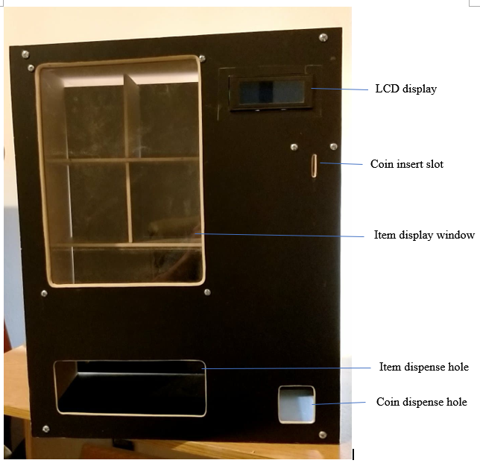

**Figure 3.** Exterior box with item shelves

### 

### Coin Counter

The design of the coin counter began with two pieces of wood separated by a distance slightly greater than the width of a nickel. The best way to distinguish between the different coins was by the size of the coins. Therefore, three different holes were drilled at different heights and a bolt was inserted into each hole. The dime can roll under the first and second bolt but is stopped by the third bolt. While the nickel, being slightly bigger than the dime, is stopped at the second bolt. Finally, the quarter is stopped at the first bolt. At each place where the coin stops there is a sensor that detects the presence of a coin. After a coin is detected, the total amount inserted is updated and the coin is release by a flap. The coin counter is shown in Figure 4. The software part is designed to ensure a 100% detection rate. Meaning that the coins are not misinterpreted. This is done by sampling the AdC multiple times to ensure that the coin is not rolling but is indeed stopped.

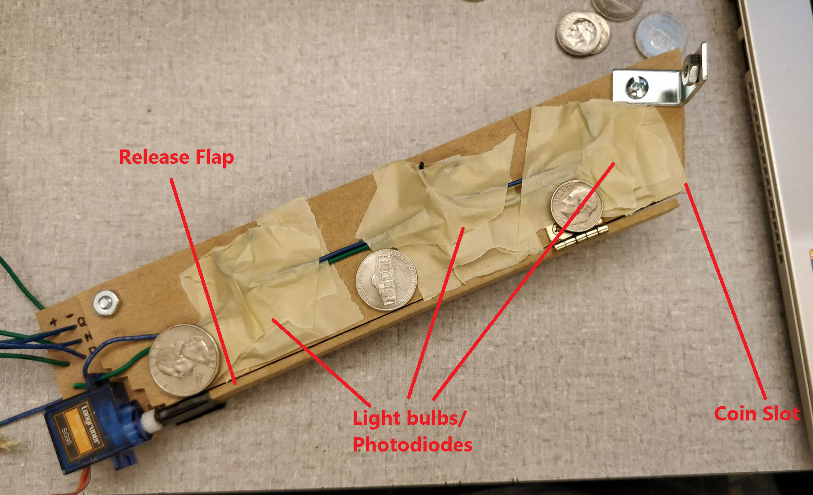

**Figure 4.** Coin Counter

### 

### Product Dispenser

The product dispenser was designed to behave like most commercial vending machines with a rotating helix that dispenses the product. Rather than making a helix from wire or a thin rod, a standard spring was used. It was modified by using a hacksaw to trim one end so that the product could fall off the end. The panel that held the springs in place was quite thin and wasn’t thick enough to hold the springs horizontally. To solve this problem a hole big enough for the spring to fit through was drilled into the panel and an additional small slab of wood. This additional slab of wood was then aligned with the hole on the panel and attached with screws. The stepper motors used had a flattened axle that was used to rotate a shaft. In order to connect to this axle a small aluminum hollow rod was purchased that was trimmed down to size and then crimped so it was no longer circular. This trimmed rod was then pressed into the cutout from the hole which happened to be the same diameter as the internal diameter of the spring. There are a total of four different springs which are divided by wood panels to create a compartment for each product. The back panel that houses the product dispenser is shown below:

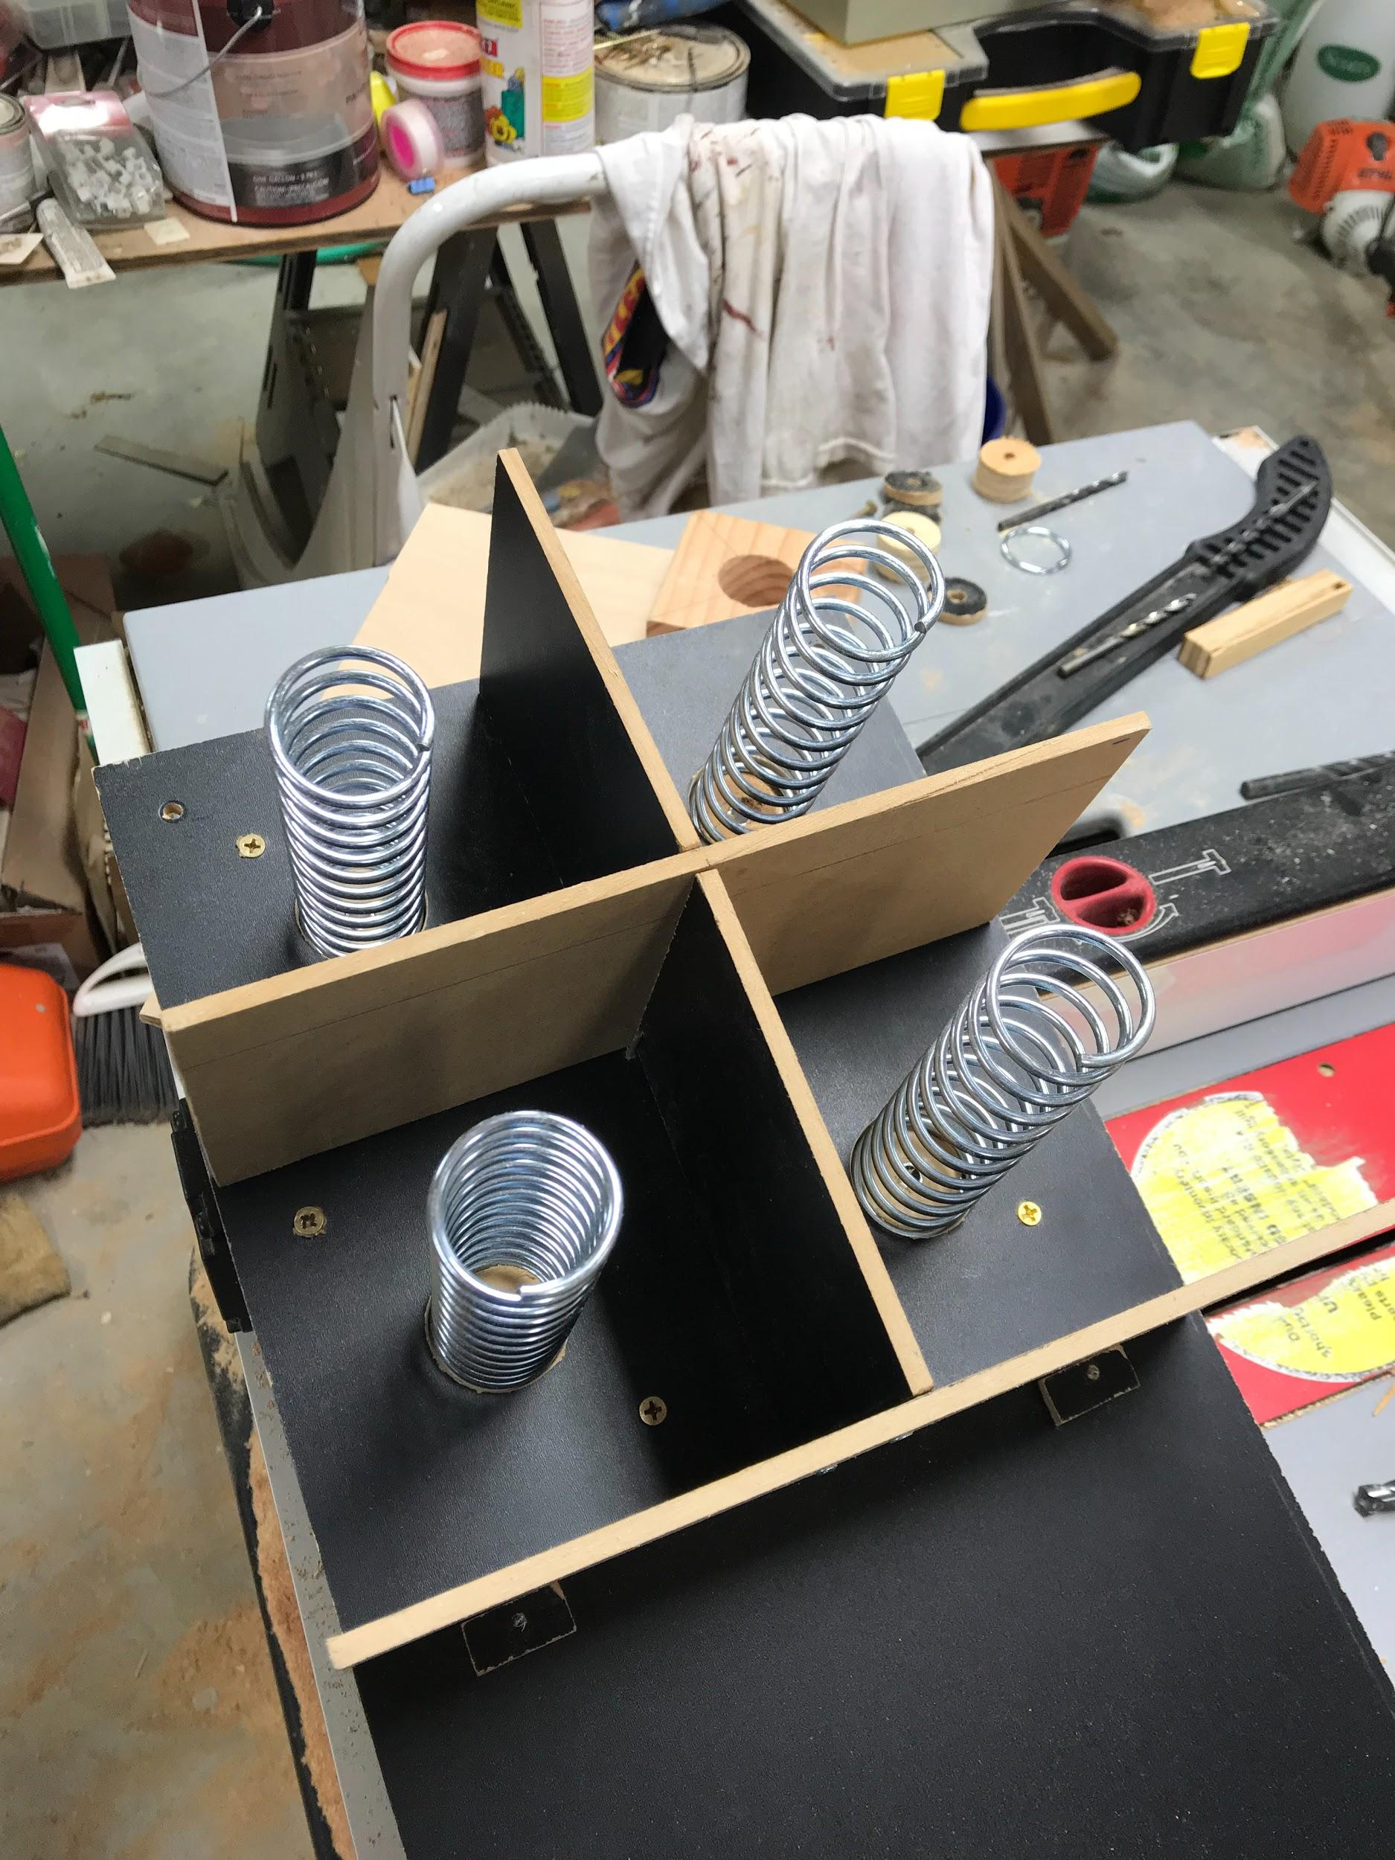

**Figure 5.**Photo showing the product dispensing helixes

### Change Dispenser

Three compartments for quarter, nickel, and dime are made by gluing together small pieces of wood panels. The bottom of all three compartments have little holes cut out for coin dispense and pushing rod to go in. Then, the bottom panel is glued to the three compartments. To push out the coins, three finely tuned thin wood panels were glued and taped to three small hex keys. The tips of the hex keys are connected to the three servo motors. To make the three wood pieces push out coins consistently, three rails are glued to the bottom panel. The finished coin dispenser is shown in Figure 6.

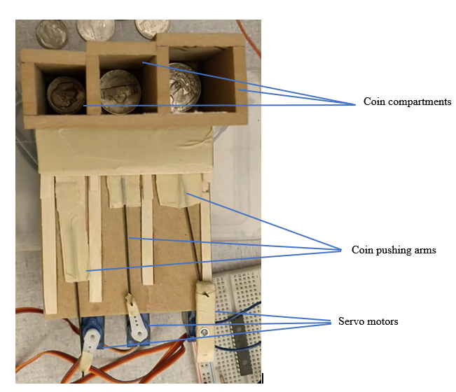

**Figure 6.** Change dispenser unit

## **System Description**

The vending machine is to be able to do the following things listed below:

1. Accept payments in the form of quarter, dime, and nickel.
2. Let user cancel transaction.
3. Display the amount of coins user has inserted, the item selection the user choose, and if enough coins have inserted for the selected item.
4. Dispense coins if the user chose to cancel transaction or if the user inserted more than enough coins.
5. Dispense the selected item.
6. Update item stock through wifi to the owner/operator.
7. Store the item stocks in EEPROM memory just in case the power is cut.

### System Inputs

The vending machine shall be able to accept the following inputs from the user:

1. Payments
   1. Quarter
   2. Dime
   3. Nickel
2. Keypad input
   1. Key 1 for item selection 1.
   2. Key 2 for item selection 2.
   3. Key 3 for item selection 3.
   4. Key 4 for item selection 4.
   5. Key 8 for transaction cancellation.

### System Outputs

The vending shall be able to output the following to the user:

1. LCD display will output the following:
   1. The amount of coins inserted by the user
   2. The item that user selected
   3. Whether or not the user has inserted enough coins for selected item.
2. The item the user selected to buy
3. Dispense coins if the user chose to cancel transaction or if the change is due.

### User Interface

The user will be able to select four different items using key 1, 2, 3, or 4. And the user will be able to cancel transaction and get back all the coins inserted by pressing key 8.

The user will be able to see the amount of coins inserted, the selection made, and whether or not enough coins is inserted for the selected item through the LCD display.

The dispensed item and coin change can be accessed through item dispensing hole and coin change hole near the bottom of the vending machine.

### Physical Structure Specification

The prototype will be housed in a physical structure that models a vending machine with a dimension of 2x2x1 foot. The front panel will have six holes in total for item display window, item dispense hole, LCD display mount, coin insert slot, keypad wires, and coin dispense hole. The item display window will be covered with plexiglass for good visibility.

The coin detection system will consist of a slanted rail mechanism that has three different stoppers at the heights of a quarter, nickel and dime. The stoppers will be put in that order, effectively allowing the smallest of coins to pass through unobstructed. When a coin hits a stopper it will block a light sensor and signal that that coin value has been inputted. At the bottom of the rail mechanism there is a trap door bottom that opens to clear the coin slot and collect the coin.

The item dispensing system will consist of four metal spiral coils that will hold the item. Those coils will be rotated by the stepper motor attached at the back.

The coin dispensing system will consist of three compartments for quarter, dime, and nickel. A thin pushing arm controlled by servo motors will push out the coins to the coin dispensing hole on the front panel.

### System Functional Specification

The vending machine is designed to dispense selected item and coins in a fast and reliable manner. The system can be divided into three major parts as seen in Figure 7.

**PIC1 -** PIC1 shall determine which key the user pressed, type of coin inserted, total amount of coins, and display those information to the user through LCD display. PIC1 will also send those information to the PIC2 through UART.

**PIC2** - PIC2 shall receive data from PIC1. Based on those information, it will output the correct coin change, and dispense the correct item. Then, PIC2 will also send the information of what item is sold to the wifi module.

**Wifi Module** - the wifi module shall receive data from PIC2 and update the item stock stored locally. Then, it will send the item stock info to the web server using wifi.

### Operating Specification

The vending machine shall operate reliably in a standard commercial/industrial environment.

Temperature Range 0-85°C

Humidity Level 0-80% non condensing

Power 5V DC

## Software Implementation

The top level software implementation is shown in Figure 7 below. When the system is powered on, the first thing that happens is initialization of memory, the system, and interrupts. Then Pic 1 and 2 go into a while loops as shown in the figure below.

### Pic 1

In the first PIC, the screen is also initialized. After the initialization, the system goes into a while loop.

First it samples the Keypad for any keys that are pressed. If Key 8 is pressed the system will send a signal to the second pic to dispense the proper change. If Key 1-4 is pressed, and the proper change was inserted, the system will also send a signal to the second pic to dispense the desired product and also to dispense the change.

Second, the three adc ports are sampled to detect if a coin is present. If a coin is detected, the system will provide power to one of the servos via a gate(MOSFET Transistor) and then it will control the flap that drops the coin via the PWM pin. If no key was pressed nor coins inserted, the loop is started over. Else it moves to screen display.

Finally, the LCD Display is updated to display the proper payment and product selection. After that the loop repeats.

### Pic 2

The behavior of the second PIC solely relies on what data is received from the first PIC through UART. Table 1 shows what the system outputs based on the received data

|  |  |
| --- | --- |
| Received Data | Output |
| a | Dispense a dime |
| b | Dispense a nickel |
| c | Dispense a quarter |
| 1 | Dispense item 1, and send a to wifi through UART |
| 2 | Dispense item 2, and send b to wifi through UART |
| 3 | Dispense item 3, and send c to wifi through UART |
| 4 | Dispense item 4, and send d to wifi through UART |

**Table 1.** Received data and output relation table

If the received data is a, the system will provide power to one of the change dispensing servos via MOSFET transistor and dispense a dime. Same goes for b and c, but each will activate different change dispensing servos.

If the received data is 1, the system will provide power to one the item dispensing stepper motors via MOSFET transistor and dispense item 1. And, it will also send data a to the wifi module through UART. Same goes for 2, 3, and 4, but each will activate different stepper motors, dispense item 2, 3, and 4 respectively.

### Wifi

The behavior of the wifi module depends on what data it receives from the second PIC. If it receives a, item1’s stock number will be updated. If it receives b, item2’s stock number will be updated. If it receives c, item3’s stock number will be updated. If it receives d, item4’s stock number will be updated.

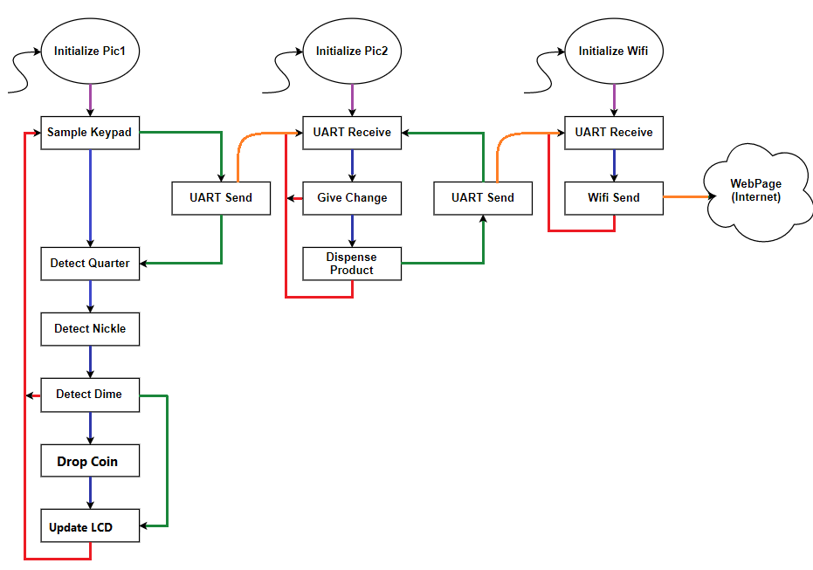

**Figure 7.** Top Level Functional Diagram

### LCD Display

A high level view of the software for the LCD display is shown in Figure 8. During pic initialization, the screen is restarted and initialized in the Initialize/Reset function. Then the Function Set sets the display too 4 lines, sets the font size, screen shift off, and cursor blink off. Then the Entry mode function sets up the LCD display to except an address and data. The SetUp Words function prints the various lines of texts as shown in Figure 9. There is also an additional function that clears the screen.

After the screen is initialized, there are two functions(Update Product & Update Total) for printing out the product selected and to update how many coins are inserted. Figure 9 highlights the two locations that are updated in a red box. Figure shows what happens when a key is pressed with insufficient funds. These functions use the helper functions that are shown on the right hand side of Figure. SetAddress function will move the cursor to a certain place on the screen while Display stuff function accepts and prints a string to the screen at the selected address location. Both these functions rely on other helper functions such as Type2Display which prints a character to a display. The Shift function controls the serial in/parallel out shift register via control lines and a serial line that feeds the data. See hardware Figure 11 for more detail.

The LCD code was set up in this way to make it easy to print and update the screen with a simple line of code after initialization.

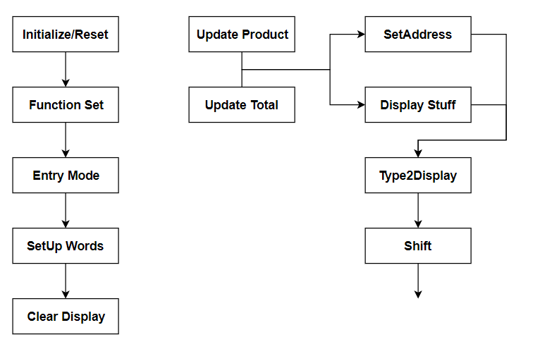

**Figure 8.** LCD Display Software

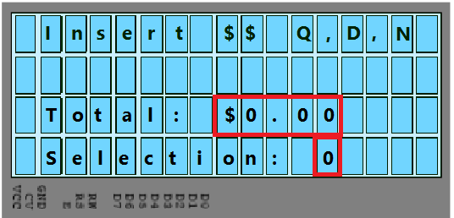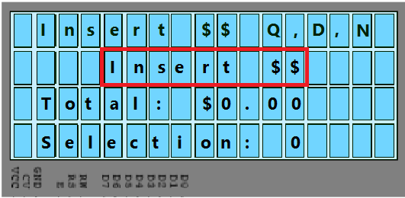

**Figure 9.** Normal LCD Display **Figure 10.** LCD Display “Add more coins”

### KeyPad

Two rows and four columns of the keypad are used. The columns PINs are set up with pull-down resistors. To determine which key is pressed, the first row is set as High, and each column are scanned through using if statements. If the first column is High, then we know Key 1 is pressed and the global variable key is set to 0x1. If the second column is High, then Key 2 is pressed and key is set to 0x2. The third and fourth columns works in a similar fashion and will set key as 0x3 and 0x4 respectively. After all the columns in the first row are scanned, row1 is set Low, and row2 is set High. Again, row2 works similarly to row1 where each column are scanned and key is set to different values.

### Coin Counter

The software for the coin counter is fairly simple. First the following variables are set up. The int Average variables will hold the sum of ADC values that are recorded in a *for* loop. The int coins Global variable will add by 5, 10, or 25 based on the coin detected. The float total variable is used to convert the int coins to a float before displaying it to the screen. The money is first added as an int and then converted to a float for display because the screen would bug out when the sum of the coins was calculated. After these variables are set up, the ADC pin is sampled. Next, a set of *if* statements are executed to determine what coin was inserted and if the flap should be opened to drop a coin. It also determines if the screen should be updated with the correct total change.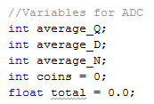

### 

### Change Dispenser

The change dispenser function will only execute if the global variable key is 0x8 or dispense variable is 1. The algorithm to determine which coin to dispense is processed in PIC1. Using while loop, while the total coin is greater than 0, we check if the coin is greater than or equal to 25, 10, or 5. If total coins is greater than or equal to 25, the total coins is subtracted by 25, then a signal to dispense a quarter is sent. Then we loop through while loop again, to check if the new total coins is greater than or equal to 25, 10, 5. Depending on which if statement is executed, the total coins is subtracted by 25, 10, or 5 respectively and a signal to dispense quarter, dime, or nickel is sent. The code will jump out of while loop when the total coins is equal to 0 which means change dispense is complete.

The actual activation of servo motors to push out the coins happens in PIC2. When the PIC2 received signal to dispense quarter, it will activate one of the MOSFETs connected to the servo, and that will push out the coin.

### Wifi

Serial communication is used to communicate with the PIC microcontroller and the server at 9600 baud rate. Initially, the wifi module will display the IP address of where the data will be sent through serial monitor. As seen on Table 1, if a is received from the second PIC, the system will update the item1 stock. Same goes for b, c, and d, the system will update the item2, item3, and item4 stock respectively. The update stocks are then sent to the server through wifi. The user can keep track of item stock by typing in the IP address printed out in serial monitor.

### Product dispenser

There is a series of *if* statements that check for each key press and if the current amount of money inserted into the machine is enough to pay for that item. If that check is *true* then it enters the *if* statement and subtracts the price of the item from the total amount of money inserted, then calls a function to return the change due to the user. This all executed on the second PIC microcontroller, the motor is controlled in a series of half steps, which is covered in detail in the hardware implementation section. It also prints the product selection to the LCD screen along with the now update amount of money due. It finally dispenses the product.

### Memory

The system uses electronically erasable programmable read-only memory (EEPROM) to store the inventory of the machine. This is important because if the system loses power for some reason the current inventory must be known when the system reboots. The on chip EEPROM for the NodeMCU was used. This involves specifying the address in memory and the char to be stored. The data can then be read with the read.EEPROM() function, with the appropriate address specified. Other things are could also be written to the EEPROM, information such as the prices or the total amount of money collected. However the EEPROM was included just to show that it was possible to do and further implementation could later be added.

## Hardware Implementation

The Vending machine is composed of many subsections that are connected to two pics. Therefore, the architectural view of the system is decomposed into individual parts to make it easier to explain and understand the system.

### LCD Display

The Hardware architecture for the LCD display is shown in Figure 11. The first major part is the screen itself. It has two separate power supplies (black = 0V, Red = 5V), one for the logic and one for the backlight (not shown in the figure). The three control lines (Green in the figure) are RW, RS, and E. They are used to initialized the screen, set up the function, specify addresses, and send data. These are controlled directly by the Pic as shown in the Figure. The eight data lines (Blue in the figure) are used to send data and addresses via the shift register. This data is fed into the shift register through the Ser line (also shown in blue) from the pic. The last line, CV, (Shown in purple) is connected to a potentiometer. This is used to control the screen brightness via a voltage between 0v - 5v.

The second part is serial in parallel out shift register. The eight data pins A-H are shown in blue. The two control lines (shown in green) control when the data is shifted. The other pins are either connected to VSS or VDD for proper functionality(See Figure 21, and 22 in Appendix for Timing and Logic diagrams).

This system could be simplified by removing the Shift register. However, we chose to implement it for personal experience and also to save some I/O pins on the pic. This set up saved us 5 pins in total. However, it significantly slowed down the entire system because each character needs to be shifted one at a time.

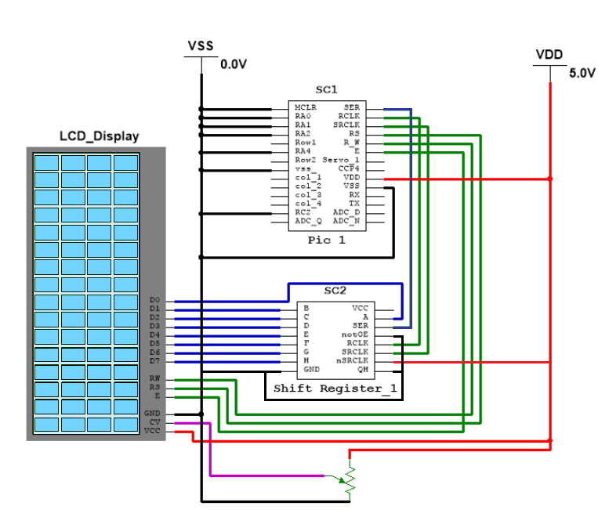

**Figure 11. LCD Display Architecture**

### KeyPad

The detail hardware and connections of the keypad is shown in Figure 12. The bottom two rows are connected to Row1 and Row2 GPIO output pins. The columns are connected to col-1, col-2, col-3, and col-4 GPIO input pins with pull-down resistors. The keypad determines which key is pressed by comparing the signal on the row to the column. Initially, row1 is set as high, and the software scans through each column for high signal. Then, row1 is set low, and the software scans through each column again for high signal. After that, row2 is set low, and row1 is set high again to repeat the whole process. For example, while row1 is high, if col-1 received a high signal, it means key1 is pressed. If col-2 received a high signal, it means key2 is pressed and so on. Same goes for row2. While row1 is set low and row2 is set high, if col-4 is pressed, it means key # is pressed.

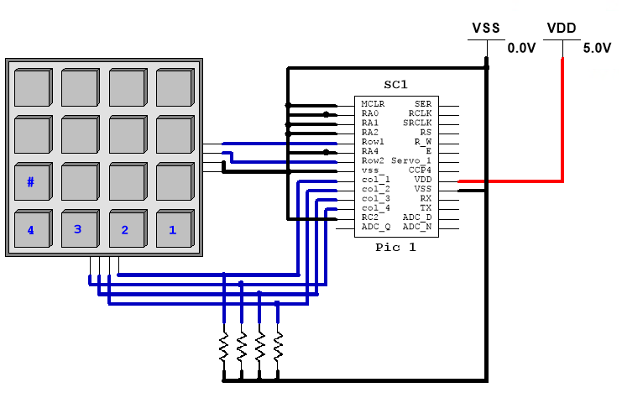

**Figure 12.** KeyPad Architecture

### 

### Coin Counter

A detailed hardware architectural view for the Coin counter is shown in Figure 13. This device decifiers between a quarter, nickel, or a dime. Basically it is two pieces of wood separated by a small distance to allow coins to roll by. There are bolts screwed in at three different locations and heights to stop the coins based on its size. At these locations, a light source is inserted at one side and a photodiode on the other side. On the left side we have two hinges, which made it easy to secure the entire device to the front panel, right in front of the coin slot. On the right side there is a servo that opens or closes a flap (located at the bottom) to drop a coin. This device was built because it guaranteed 100% detection rate. Because the coin is stopped, and then manually dropped, it is guaranteed that the device will detect the presence of a coin. Therefore, this device was chosen over another prototype which detected the coins only as they rolled by. The photodiodes were used instead of other sensors such as magnetic or distance sensors because it was cheaper. Photodiodes cost around 25 cents while other sensors are over $10 each.

As before, the two power supplies are shown in red and black lines. One is used to power the pic controller and the photodiodes, while the other one powers the light sources and the servo. The ground is shared between the two sources because of the Servo.

As shown in the Figure 13, one lead of the photodiodes are connected to power, while the other leads are connected to the adc ports and a resistor, which is then connected to the ground. When the photodiode is exposed to light, current is allowed to flow through the resistor which means there is positive voltage at the resistor, which can be detected by the ADC port. However, when a coin is stopped by a bolt, the light is blocked off from the photodiode creating an open circuit. Therefore, the ADC port detects 0V at the resistor since no current flows through it.

After a coin is detected, the Servo_1 output pin (shown in orange) powers up the servo via a MOSFET transistor. When power is supplied, the CCP4 provides a 50Hz signal that controls the position of the flap. At a 1.5ms pulse the flap is open, at 2ms pulse the flap is open. We chose to cut out the power for the servo to save power and also to reduce noise.

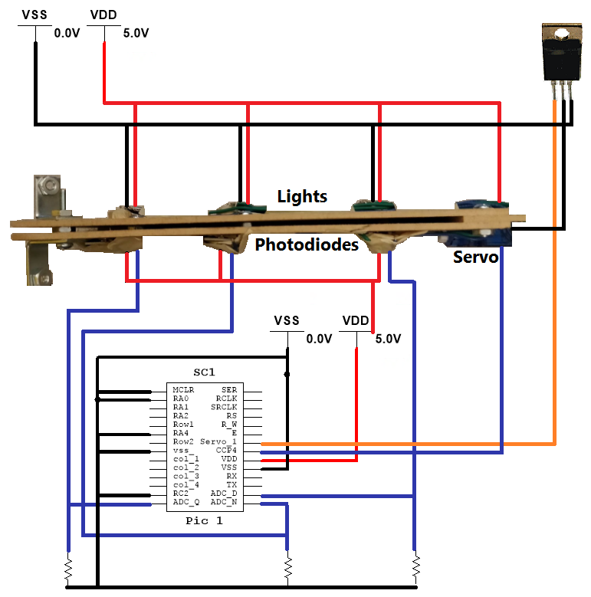

**Figure 13.** Coin Counter Architecture

### 

### Change Dispenser

The detailed hardware design and connections of change dispenser is shown in Figure 14. This device dispense one coin at a time. Change dispenser is made up of three main components which are the physical coin compartment made up of wood, three servos, and three MOSFET. Each servo motor has one VDD (red lines), one PWM (green lines), and one Gnd (black lines) pins. The VDDs of all servos are connected to the power supply. The Gnds are connected to the drain gates of the MOSFET. The PWMs are connected to the CCP4 pin of the PIC. The source gates of the MOSFETs are grounded, and each ground gate to D_Q, D_D, D_N pins of PIC.

The PIC will receive data from another PIC. Based on that data which can be seen on Table 1, it will activate D_Q, D_D, or D_N pins. If D_Q is activated, the rightmost servo will activate and dispense a quarter. If D_D is activated, the leftmost servo will activate and dispense a dime. If D_N is activated, the middle servo will activate and dispense a nickel.

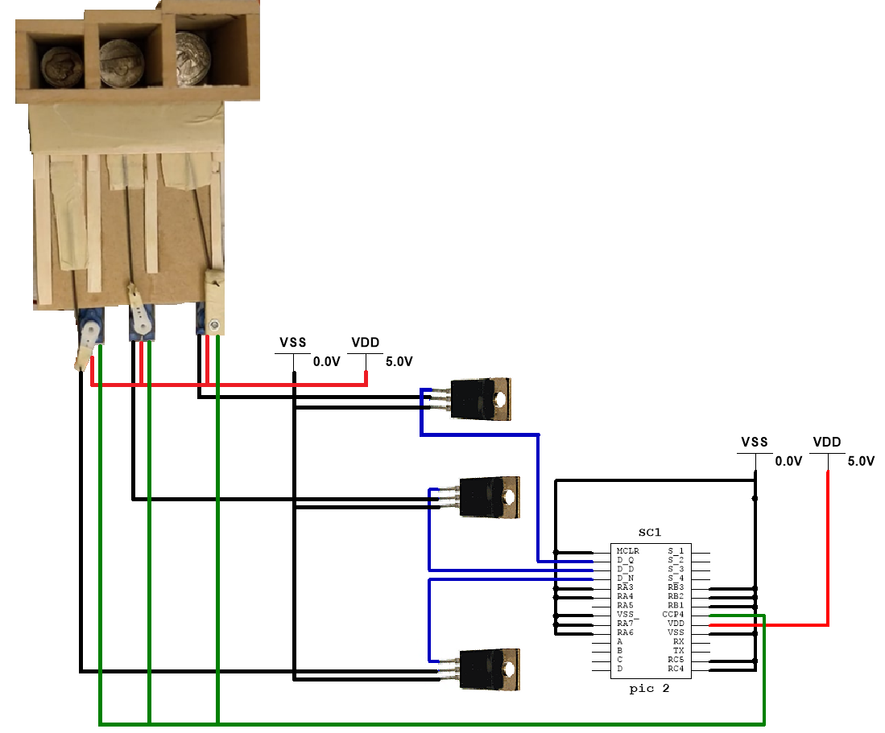

**Figure 14.** Change Dispenser Architecture

### 

### Wifi

The connection and setup of the Wifi module is shown in Figure 15. The TX pin of the PIC 2 is connected to the RX pin of the wifi module. Based on the data received, the wifi module will update item stocks.

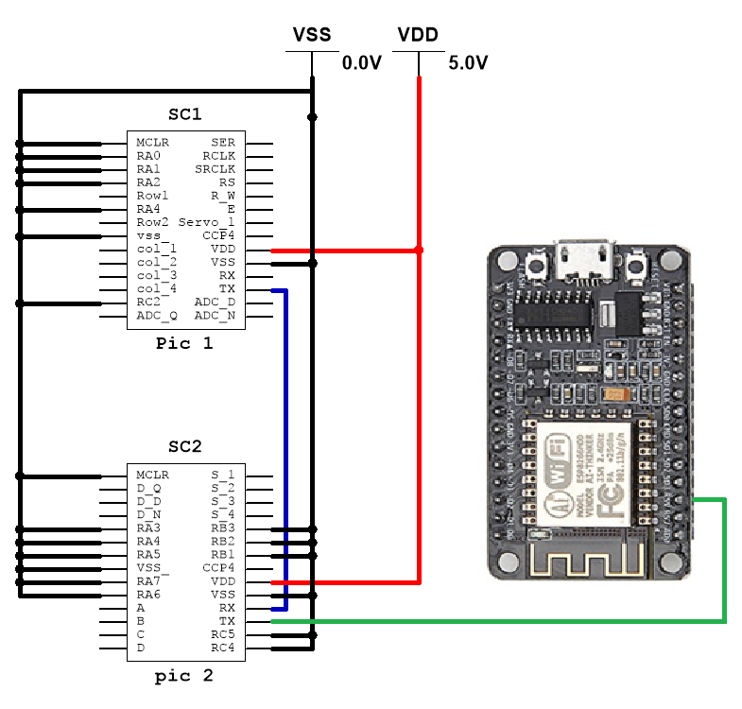

**Figure 15.** Wifi Architecture

### Product dispenser

The detailed hardware design and connections are shown in Figure 16. The four springs were rotated by small stepper motors. One issue was that the limited number of PIC microcontroller pins. The stepper motors came with individual motor drivers that take four input signals that activate each phase of the motor. Half stepping is a way of subdividing the length of the motor step into a finer resolution. This is done by turning one phase on then two phases on, repeating this in a circle around all four phases of the motor. This allows for a smooth rotation and cuts out choppiness. Each stepper motor driver has four input pins that control the movement, so rather than taking a total of sixteen pins on the PIC, the control pins were all tied together taking up four pins on the PIC. Four transistors were used to cut power off to the three motors that were not being used. This also took four pins on the PIC, this work around with the transistors cut down the number of pins used on the PIC from sixteen to eight.

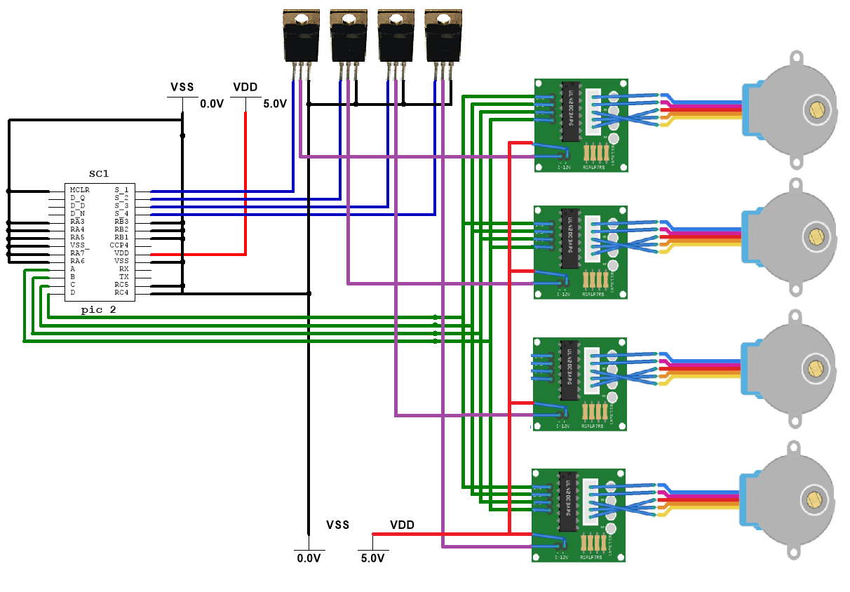

**Figure 16.** Product Dispenser Architecture

### Memory

The memory was implemented on the on chip EEPROM of the wifi module. This is efficient because it makes use of hardware that already had to be included in the design so reduces cost and physical hardware space.

# **Test Plan**

The testing of the system starts at each individual part. First the coin counter needs to be tested if it can detect the different coins properly. Additionally, the ADC timing is tested to speed up the system maintaining 100% detection rate. Next, the change dispenser needs to dispense the correct amount of change. The LCD display needs to display the correct product selection and amount of money inserted. Additionally it notifies the user if more coins need to be inserted. The product dispenser needs to dispense the correct item based on what key is pressed. It also needs to turn the coil by a certain amount to dispense the product properly. The wifi module is tested to ensure that the correct data is sent when a product is dispensed. The keypad is tested to ensure that each press is detected. Furthermore, the sampling frequency is test to obtain a balance between timing and detection rate. After testing all the parts separately, the entire system is tested for smooth and correct performance.

# **Test Specification**

## LCD Display

The LCD display is tested together with the shift register. The first test ensure that the power supply of 5v is supplied to both the logic portion and the backlight. The second test is performed on the brightness level. A signal (Input) between 0v - 5v is provided by the potentiometer, a voltage of 4.7V provides the best results(Output). The next test ensures that the control lines are held high or low based on the logic diagram shown in figure . After this, the data lines (Inputs) at the screen are analyzed for 5v when held high, or 0v when held low. The last thing to test for is the speed of the shift register. The speed of the system is limited to how fast the I/O pins on the pic can change, and also how fast the shift register can shift without distorting data (Outputs).

## KeyPad

The two rows and four columns of the keypad is tested to ensure the key presses are register on the software side. Two pins for two rows are connected to two output GPIO pins of the PIC. Four pins for four columns are connected to four GPIO input pins of the PIC. This test needs to ensure that when key 1, 2, 3, 4, or 8 is press, the software register the key press and transmit data 1, 2, 3, 4, or 8 respectively to the serial monitor.

## Coin Counter

The first tests are carried out to ensure that the coin counter is stable when no coins are inserted. This means that the light source must be bright enough to allow current to flow from +0V to 5V. Furthermore, the value of the resistor needs to be high enough to keep a positive voltage at the ADC pins. The next tests are carried out when a coin is inserted. At this point, the value at the resistor and ADC pins needs to be 0V. After this, the speed of the system needs to be tested. This ensures that a coin is not incorrectly detected while it roles by another sensor. The last part is the servo that drops the coin. The frequency of the signal must be 50Hz with a pulse of 1.5ms or 2ms for the two positions of the flap.

## Change Dispenser

The change dispenser needs to be able to dispense the nickel, dime, or quarter flawlessly without getting stuck. To dispense quarter, the holes where the quarter goes out and where the pushing arm comes in are big enough for smooth motion. Same goes for nickel and dime where the holes needs to be ensured they are just slightly bigger than the objects coming in and out. After that, the pushing arms for different coins needs to be slightly thinner than the coins they are pushing out. And finally, the servos attached to the pushing arms, need to be able to push deep enough to push out the coins and retracts far enough to pull the pushing arms out of the coin change stack.

## Wifi

The wifi module needs to be able to accept serial data through UART and store the data locally. The wifi module also need to be able to print out data on the web server using html.

## Product dispenser

It is important to test that the correct stepper motor is spinning when the respective choice is made on the keyboard. It also must be ensured that the motor does not spin too much or too little. If the motor spins for too brief of a time then the product won’t move far enough to fall down and clearly if it spins too much then the machine may erroneously dispense products and lose money. On the physical structure side of the design it must be ensured that the hole that the helix sits in is big enough that there isn’t too much friction for the motor to overcome, on the other hand if the circle is too big then the helix will not protrude straightly and will droop down.

## Memory

It is important to ensure that a range of different addresses in memory can be written to as well as different characters. The system then needs to be turned off and when it is turned back on, those same addresses need to be read from. If the data matches up then the EEPROM is being written to successfully and meets the purpose of the design.

# **Test Cases**

## LCD Display

The power supply needs to be tuned to 5v while observing the voltage with a voltmeter. The voltage desired 4.7V is tested with the voltmeter while the potentiometer is adjusted. The control and data lines are tested with the logic analyser against the logic diagram shown in figure . Finally, the speed of the shift register and the screen are tested with different delay lengths in the C code. The best speed is chosen based on whether the screen displays the expected text.

## KeyPad

The pin layout of the keypad is shown in Figure 17. The columns(X1-X4) are connected to pull down resistor. To detect which key is pressed, row 1(Y1) is set as high. Then the columns(X1-X4) are scanned one by one by the software to detect any highs. If X1 is high, then key 1 is pressed. If X2 is high, it means key 2 is pressed. If X3 is high, it means key 3 is pressed. If X4 is high, it means key 4 is pressed. Then, Y1 is set as low, and Y2 is set as high. The same procedure of scanning through the columns is repeated to detect key 5, 6, 7, and 8 key presses.

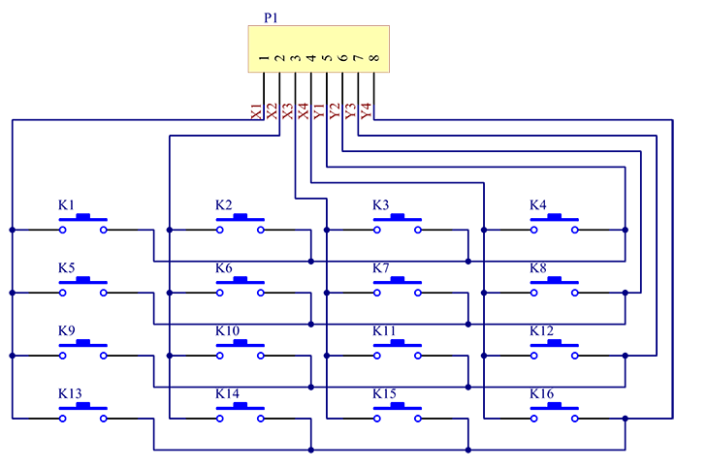

**Figure 17.** Keypad pin matrix

## Coin Counter

The first tests that ensure that the coin counter is stable, can be visually observed after the system is powered on. If the servo opens and closes the flap uncontrollably then the light source is not bright enough. The next step would be to connect a voltmeter at the ADC port to look for the desired voltage. In addition, the ADC value can be printed out for debugging purposes. Finally, the speed of the system is tested by changing how many times the ADC pin is sampled. A greater sampling rate ensures that the coin is not moving, but stopped at the correct location.

## Change Dispenser

Firstly the holes where the coins come out and pushing arms come in are tested to ensure they are big enough. Quarter, dime, and nickel are loaded to their compartments respectively. Instead of using servos, the pushing arms are controlled by hand to mimic the dispensing mechanism. This ensures that we know the holes are big enough and the pushing arms are thin enough. Next, the pushing arms are connected to the servos which are controlled by the PWM of the PIC. The servos are tested multiple times with different PWM values to ensure that the angular displacement of the servo is big enough for pushing and retracting mechanism.

## Wifi

To ensure the wifi receives data through UART from the PIC, the variable data is set to Serial.read() function. Then, data is printed out to the serial monitor on the PC to make sure the data is correct. Then, to test the webpage, a couple lines of html codes are sent to the server by calling client.print() function multiple times. Finally, from a PC, the IP address of the wifi module is opened from the web browser to make sure the html codes work.

## Product dispenser

First each motor must be tested to ensure that it performs properly when the appropriate control voltages are applied. Once it is confirmed that all of the stepper motors aren’t faulty they can be mounted on the rear side of the panel. Then the helixs can be inserted into the circular hole that holds them. Power should then be applied to the motors to see if the spring is able to spin the hole. If it is too tight then the spring should be removed and the hole can be slightly enlarge by using sandpaper to sand the inside of the hole. This must be done in small incremental steps because if the hole is made too large that will cause irreversible problems. Once all the springs have been installed in their respective holes and ensure that the stepper motors can rotate them in a smooth fashion, the next step is to check that the keypad can power the correct stepper motor and that all wiring to the transistors is correct.

## Memory

A for loop that specifies a range of different addresses can be used to write known data to a series of addresses. So for example write the char 512 to the address 512. Then the wifi module will be turned off and the test will read from those same series of addresses, if the data matches the address then the test is successful and the EEPROM working correctly.

# **Analysis of Results**

The completed vending machine’s front, back and internals are shown in Figures 18, 19, and 20.

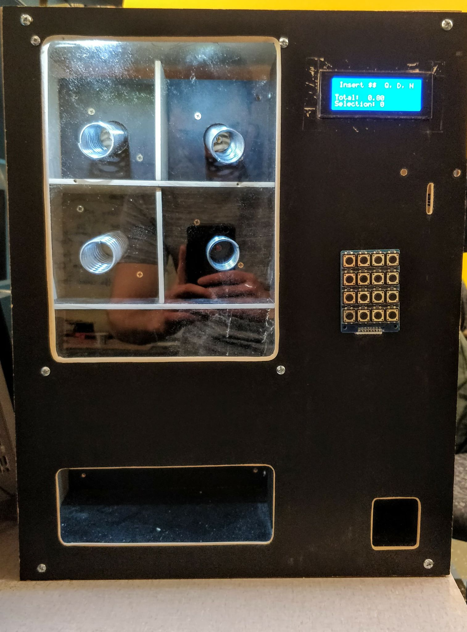

**Figure 18.** Completed vending machine front

**Figure 19.** Back side of the vending machine **Figure 20.** Internal circuit board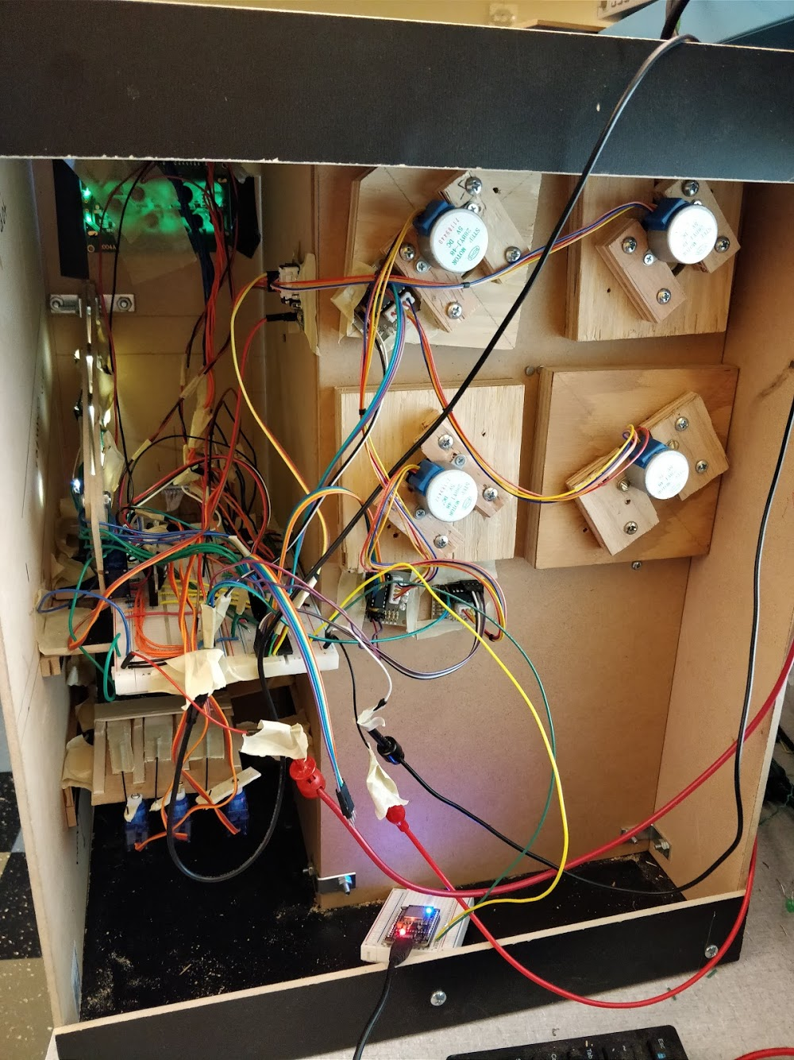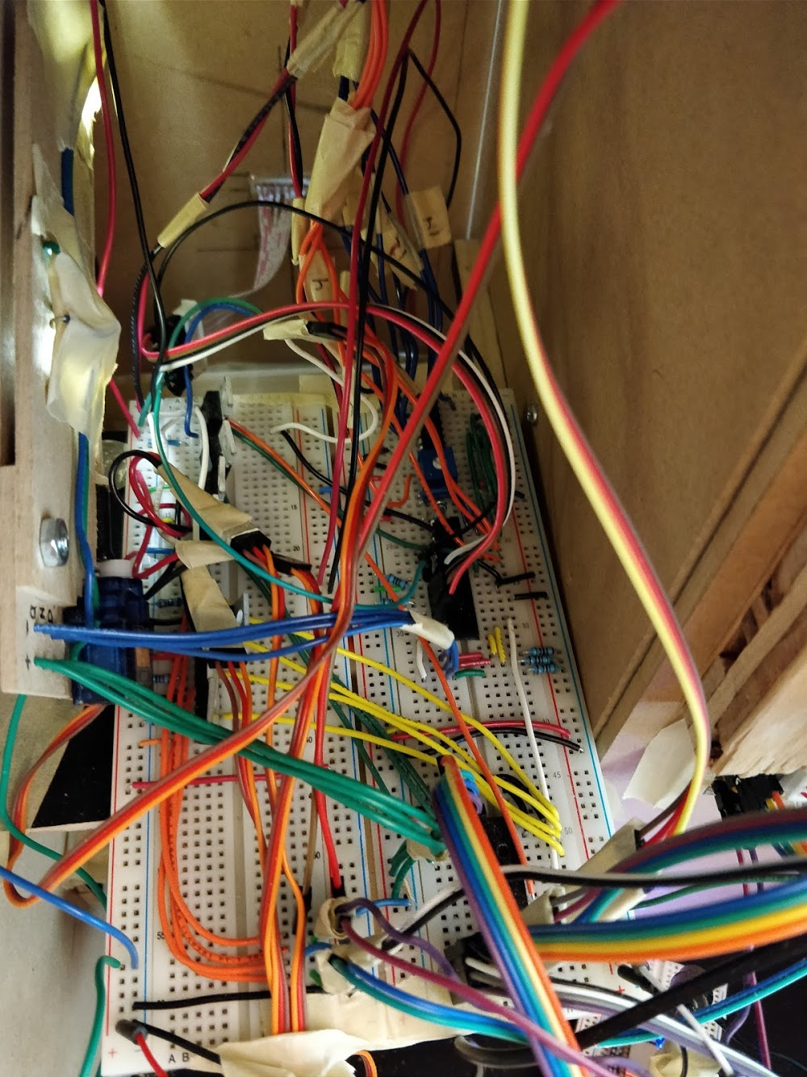

## LCD Display

The LCD Display performed better than expected. The 4x20 display provided enough room to print out all the necessary information. In fact, there was extra room to print off a “rolling” message that told the user to “Insert more $$.” The correct $$ amount and product selection was displayed in sync with the users input. The speed of the display was fast enough despite printing one character at a time through a shift register. Additionally, the light blue backlight improved the visual aspect of the vending machine.

## KeyPad

The keypad performed close to optimal when tested separately. The software recognized every key presses every time. There was minimal key debouncing issue but that only happens when the user is smashing the button multiple time with fairly fast pace. In actual use case scenario, the user will only be pressing once at max so it was deemed not an issue. When implementing into the whole system, the keypad still works as intended but with a little delay which will be discussed in the error analysis section.

## Coin Counter

The coin counter also performed better than expected. This is a result of a robust design and because it was built out of durable material. The coin detection was rather slow because of the other parts of the system. However, it was capable of keeping up with the user even when the coins were inserted at a fast pace. The detection rate was slightly lower than 100% during the demo, however, this can be easily fixed by a greater ADC sampling rate. Furthermore, a coin catcher and sorter could also be implemented to keep the coins from rolling all over the interior of the vending machine.

## Change Dispenser

The change performed flawlessly. This is the result of rigorous testing during development. Once the servo is activated, coins will be pushed out and dispensed one at a time. It takes less than one second to dispense out a coin so it’s a very fast mechanism. Surely, there are rooms for improvements such as instead of using hex keys to connect the arm to the servo, proper gear wheels setup can be used to make it more robust and clean.

## Wifi

The minimum requirement for the wifi module is achieved. That is the wifi module is able to communicate with PIC microcontrollers, and is able to send data to the wifi. The wifi module can receive item stock data from the vending machine, and dump the data to the web server. There are room for improvements on this part. One of them is the wifi module sending push notification to the operator if the item stock is nearly empty or empty.

## Product dispenser

The product dispenser proved to work well enough for the demo but not well enough to work flawlessly. In the design stage is wasn’t decided how the products would sit in the helix so that they wouldn’t get lost before they made it to the edge. Originally the springs were going to be lined with three guard rails that kept the product in place, the issue with this is that it would have involved a lot more woodworking and that it would seriously limit the size of the product being dispensed because the springs were roughly an inch in diameter. A last minute idea was to cut cardboard ‘U’ shaped pieces out that sat upside down on the spring, the pieces were cut to the width of the compartment, this ensured that they did not rotate before making it to the edge. One key problem with the helixes was that they could have been cut a bit shorter, the two springs on the top would drop the cardboard piece and it would occasionally get stuck on the spring directly below it, which was less than ideal. If there was more time for the project the two changes that would greatly improve the performance would be shortening the springs and adjusting the amount of rotation from the stepper motors to get the perfect delivery.

## Memory

While the initial plan called for using external EEPROM, this proved hard to implement with the wifi module. So instead the on chip EEPROM of the wifi module was used, which turned out to work fine and actually is a better design because it reduces the total cost and saves precious internal space in the vending machine.

# **Analysis of Errors**

There were many errors and bugs that were encountered and fixed. One overall all errors was the limited I/O pins. This was solved with two major steps. The first was to use a second microchip via a UART connection. The second was to use transistors to cut off power to motors that weren’t being used. For example, the stepper motors require four control signals, and we had four stepper motors. With transistors the required pins were cut from 16 to only 8 by having 4 lines for control, and 4 lines to control the transistors.

Many of the errors were first encountered in the coin counter. One of the problems happened when a coin was detected and a servo opened the flap. After this, the servo would repeatedly trip out. The easy solution was to separate the power supply from all motors and the pics + ADC pins. Another source of error was the brightness of the lights. The simple LEDs were swapped out with bright leds that allowed more current to flow through the photodiode. This is when another bug was discovered. The initial resistors that held the voltage at a higher potential at the ADC pins were to small. The voltage was increased by increasing the resistance, and after that the ADC pin was able to detect a clean signal.

There were also many bugs with the LCD screen. The screen would not work everytime it was rewired. This happened because the architecture of the screen and shift register was complex. This problem was solved by carefully analyzing each connection.

The keypad also has a little bit of delays. The delays were not an issue when testing it separately but it became an issue. It still works but the user has to press and hold the key for about 0.5 seconds. This happened because of the multiple delay functions calls in other functions. This issue could be solved by using interrupts but there wasn’t enough time to change the code and debug again.

Wifi module is supposed to have push notification feature, but because of time constraint, it was implemented.

# **Summary**

The vending machine was able to meet all of the specified system requirements. The system was housed in a wooden box that had a front panel that allowed the user to interface with the system. There was a plexiglass panel that allowed for viewing of the products, an LCD screen to display the user selection and the amount of money inserted into the system. A coin slot for taking in quarters, nickels and dimes. Two receptacles, one for collecting the product and one for receiving change. The user was able to select the product or cancel their transaction through a keypad.

The system was tested with a series of test cases and ensured to meet the system and functional requirements. All components were tested individually as well as tested once integrated into the system as a whole.

In terms of the finished product, it had a clean finished look. Almost all of the electronic hardware functioned as intended, with very robust coin detection and a reliable coin return mechanism the system performed well. The only major issue being the product dispensing mechanism would occasionally get the product stuck, however this is more of a mechanical engineering problem rather than an embedded systems issue.

# **Conclusion**

All in all this project turned out extremely well. It was risky undertaking a project that required significant wood working skills and a external structure that was fairly complicated. The basis for this project was fairly simple but allowed for the inclusion of a lot more complicated digital hardware that made the project a lot more impressive in the end. The wifi module and the unique coin detection system are examples of taking a simple vending machine and improving it beyond the fundamentals. We strongly urge the EE department to invest in our cutting edge technology and equip an E-vending machine in every lab in the EE building. Never again will an EE student be stuck with a burned out PIC...

# **Citations**

[1] Beta-estore.com. (2018). *LCD Module 2004A*. [online] Available at: https://www.beta-estore.com/download/rk/RK-10290_410.pdf [Accessed 14 Mar. 2018].

[2] Ti.com. (2018). *SNx4HC595 8-Bit Shift Registers with 3-State Output Registers*. [online] Available at: http://www.ti.com/lit/ds/symlink/sn74hc595.pdf [Accessed 14 Mar. 2018].

[3] Wiki.sunfounder.cc. (2018). *4X4 Matrix Keypad Module*. [online] Available at: http://wiki.sunfounder.cc/index.php?title=4X4_Matrix_Keypad_Module#Experimental_Principle [Accessed 14 Mar. 2018].

## Hardware

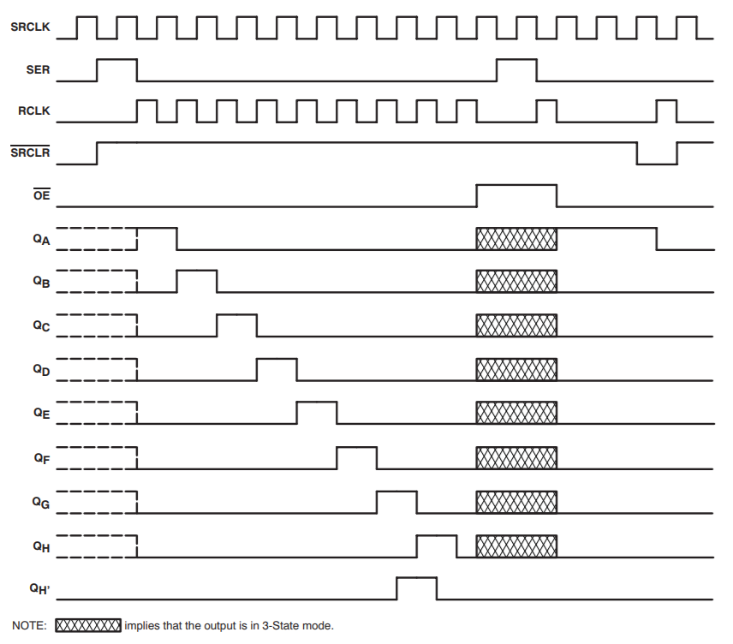

**Figure 21.** Timing Diagram for Shift Register

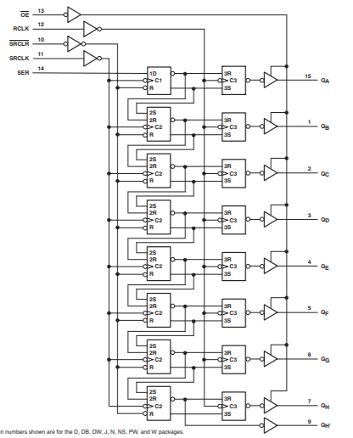

**Figure 22.** Logic diagram for Shift Register

## Pic 1 Code

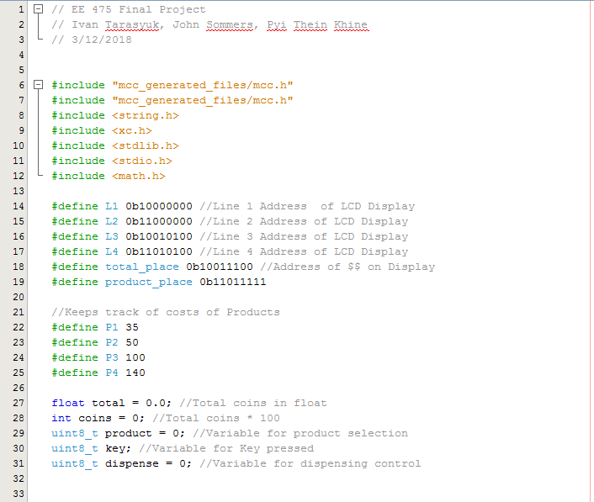

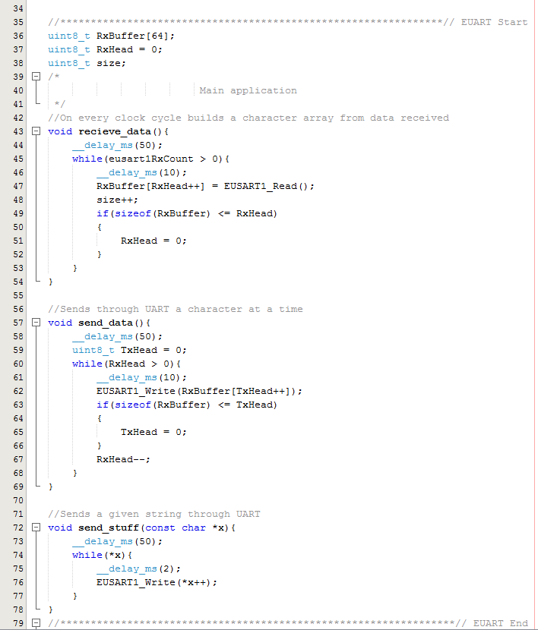

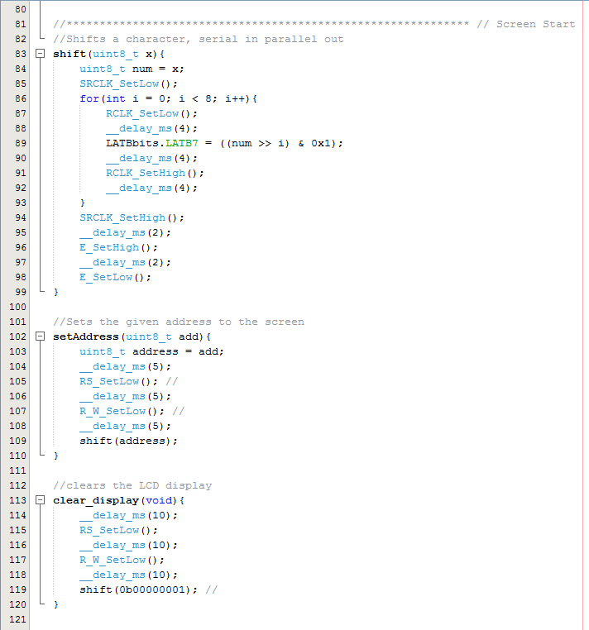

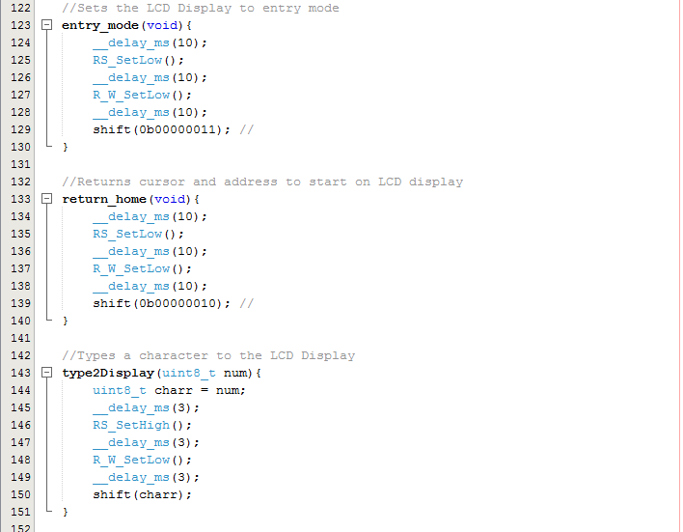

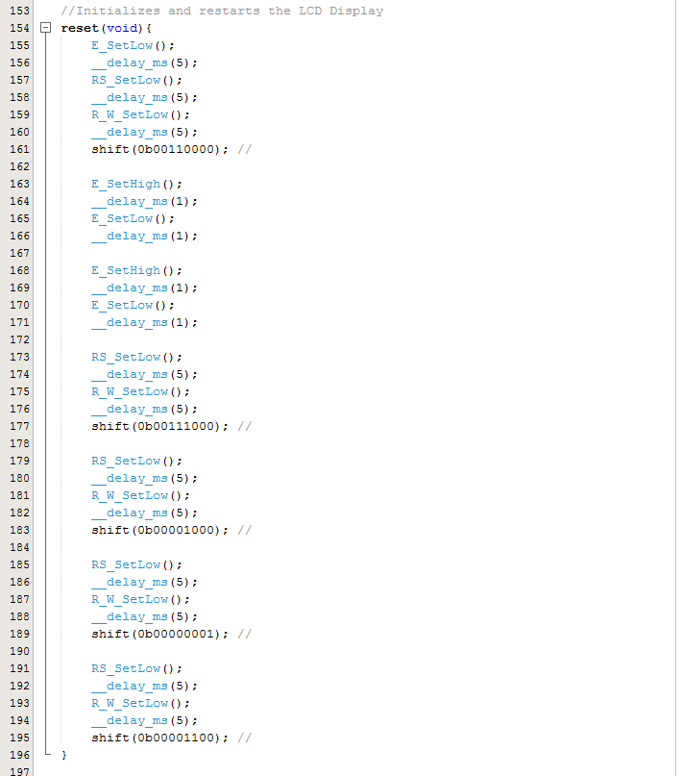

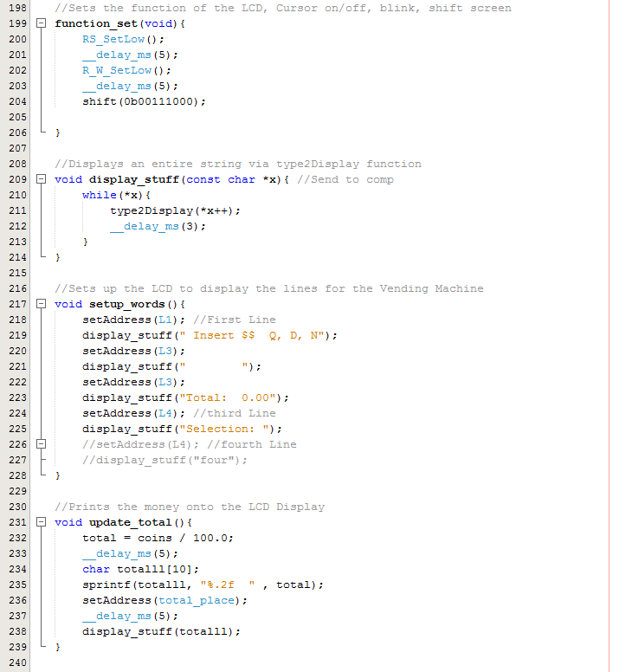

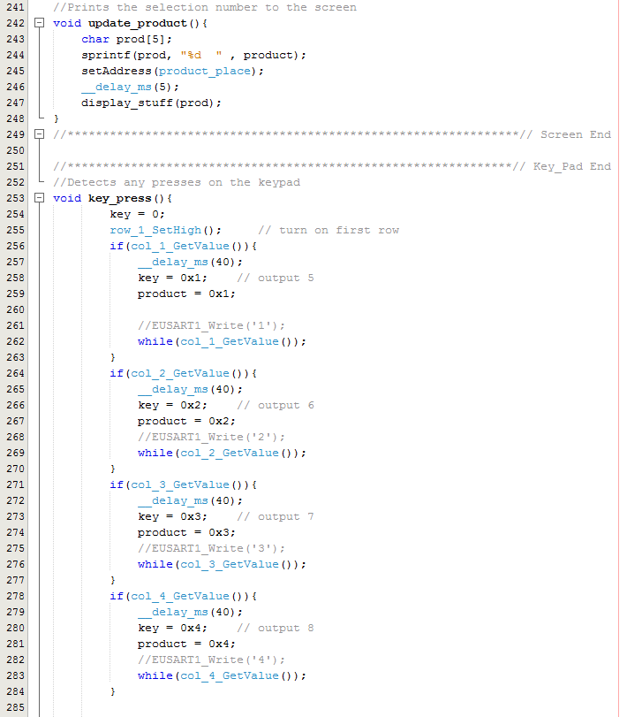

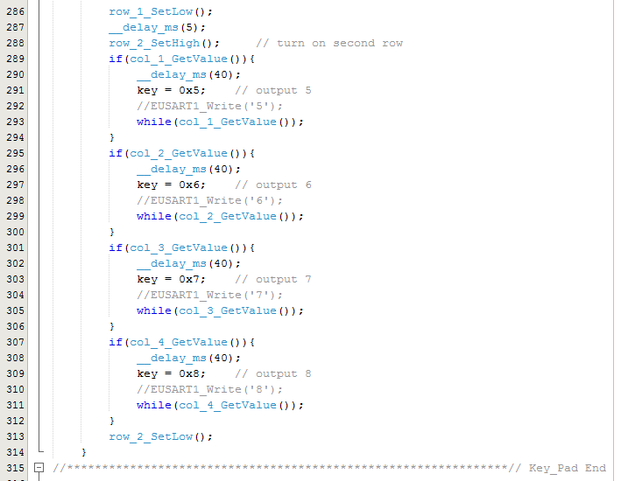

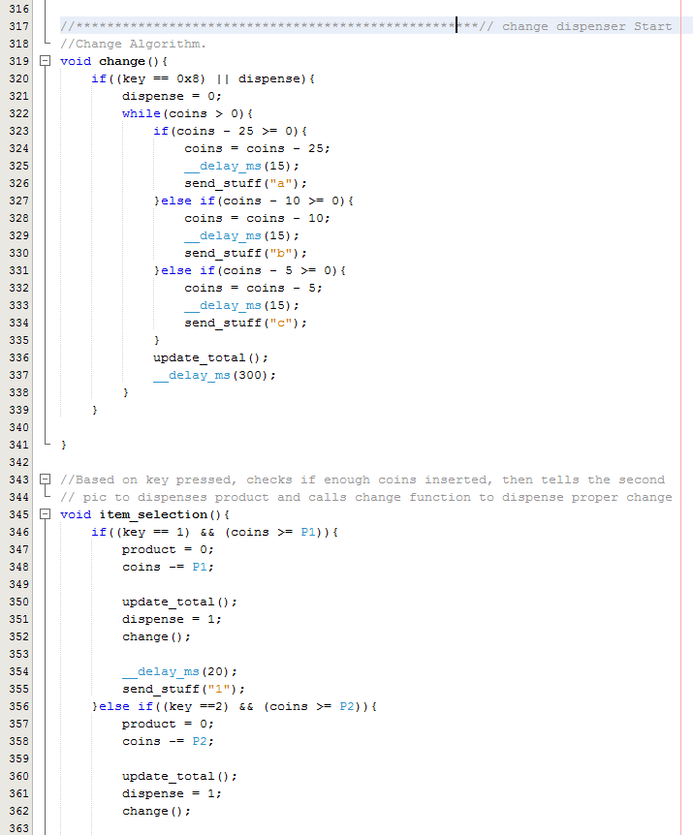

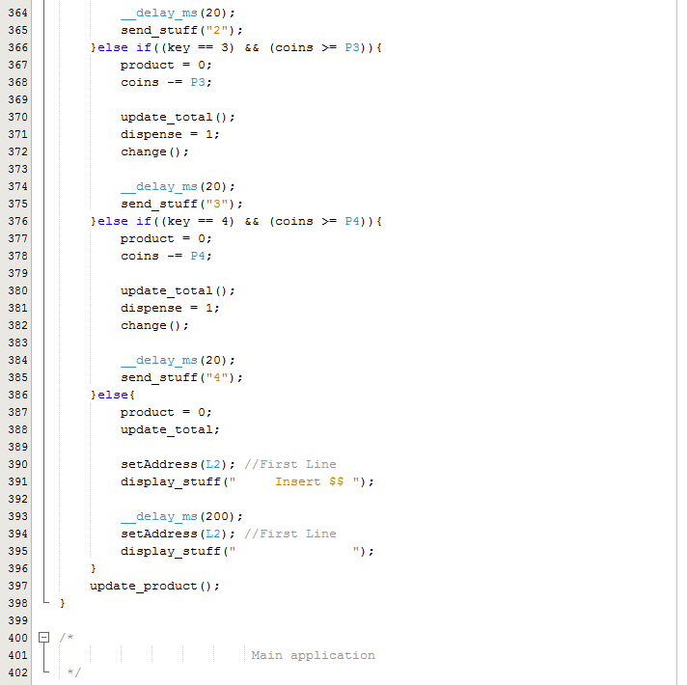

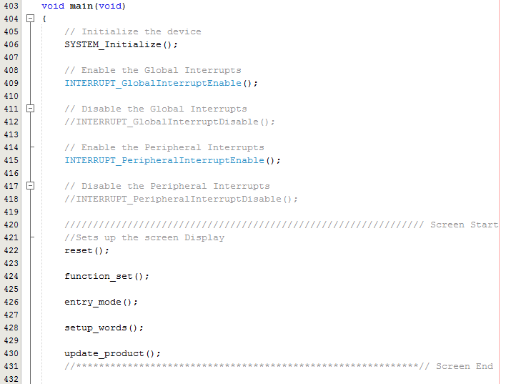

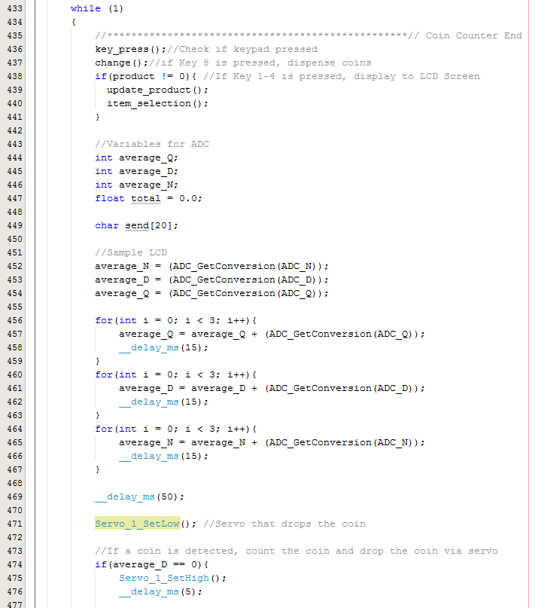

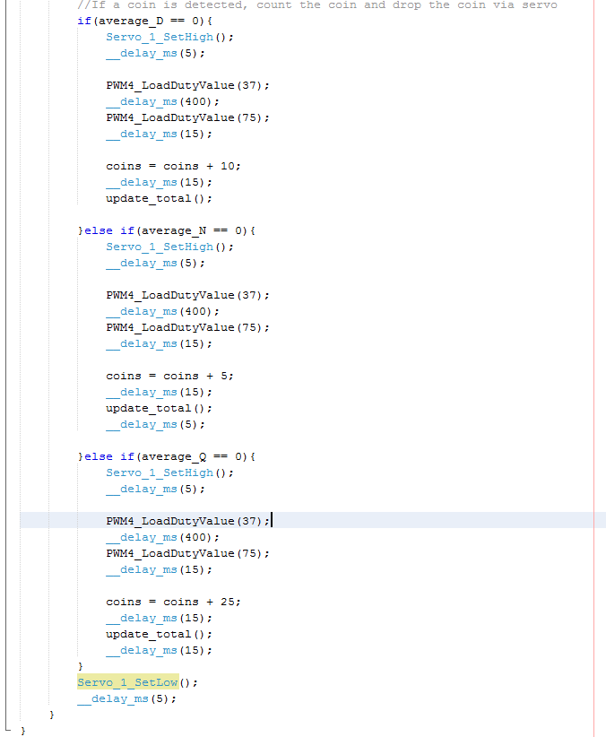

## Code for Pic 2

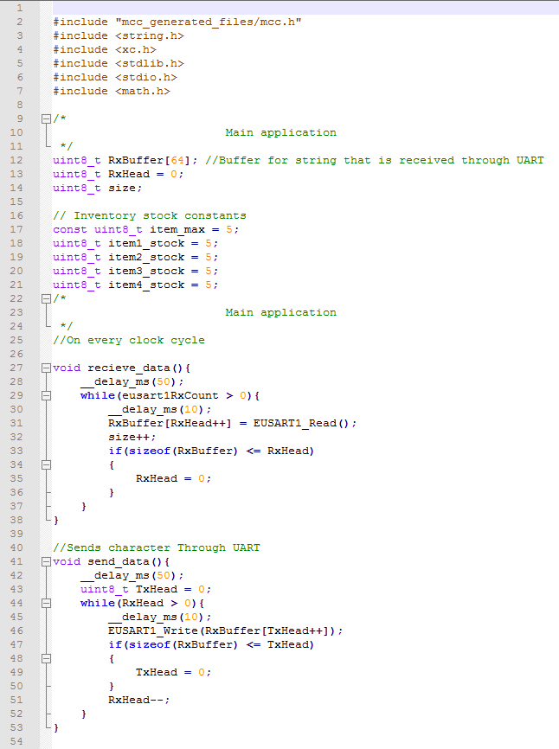

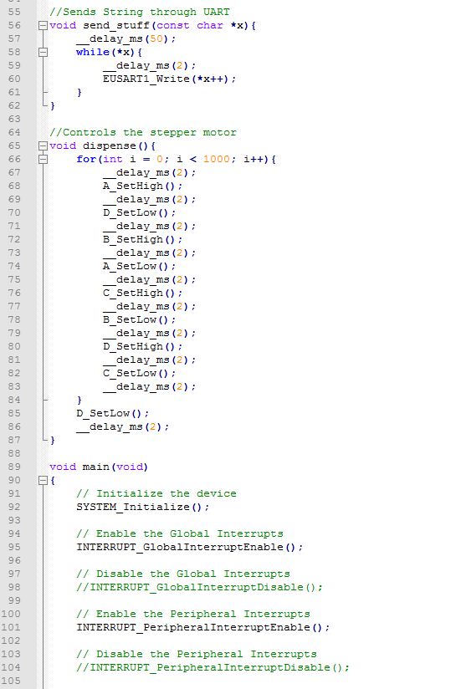

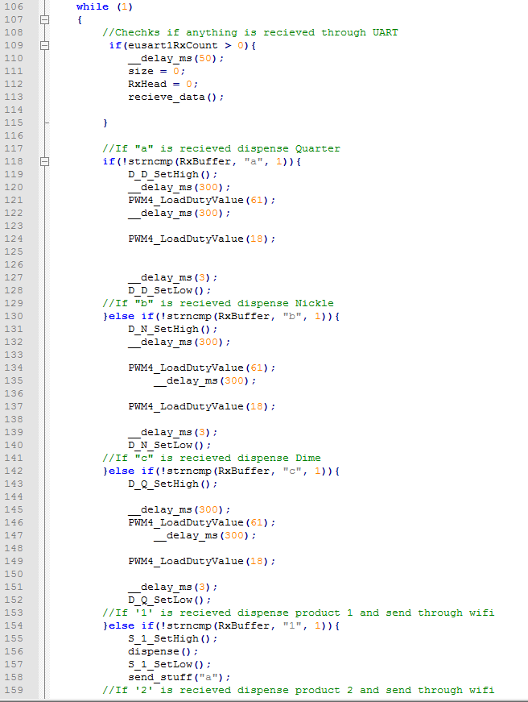

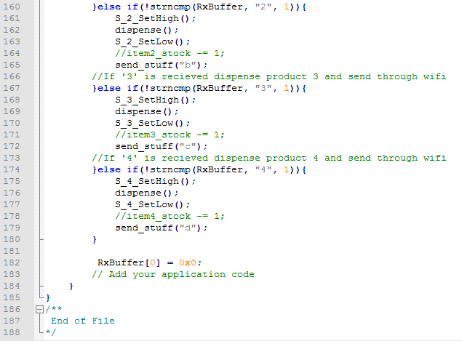

## Code for Wifi Module

